# Task 3 Report

Team ID: CS_H19

Mohammed Ashraf 20191700509

Mostafa Labib 20191700646

Mostafa Hesham 20191700656

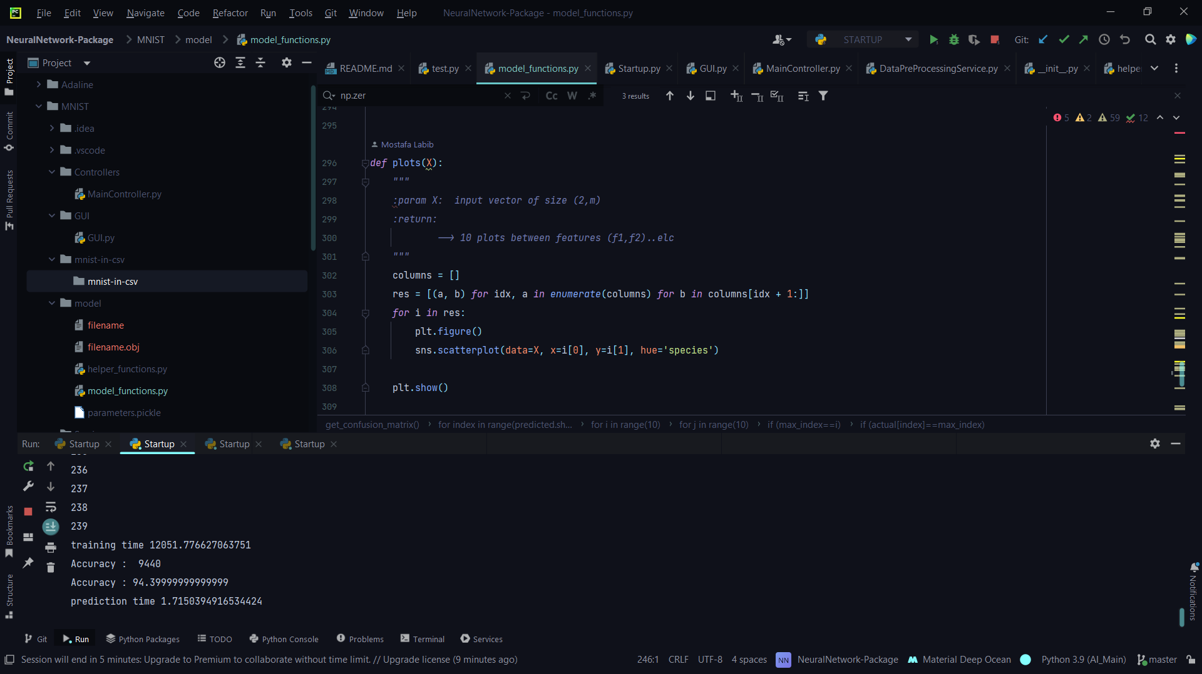

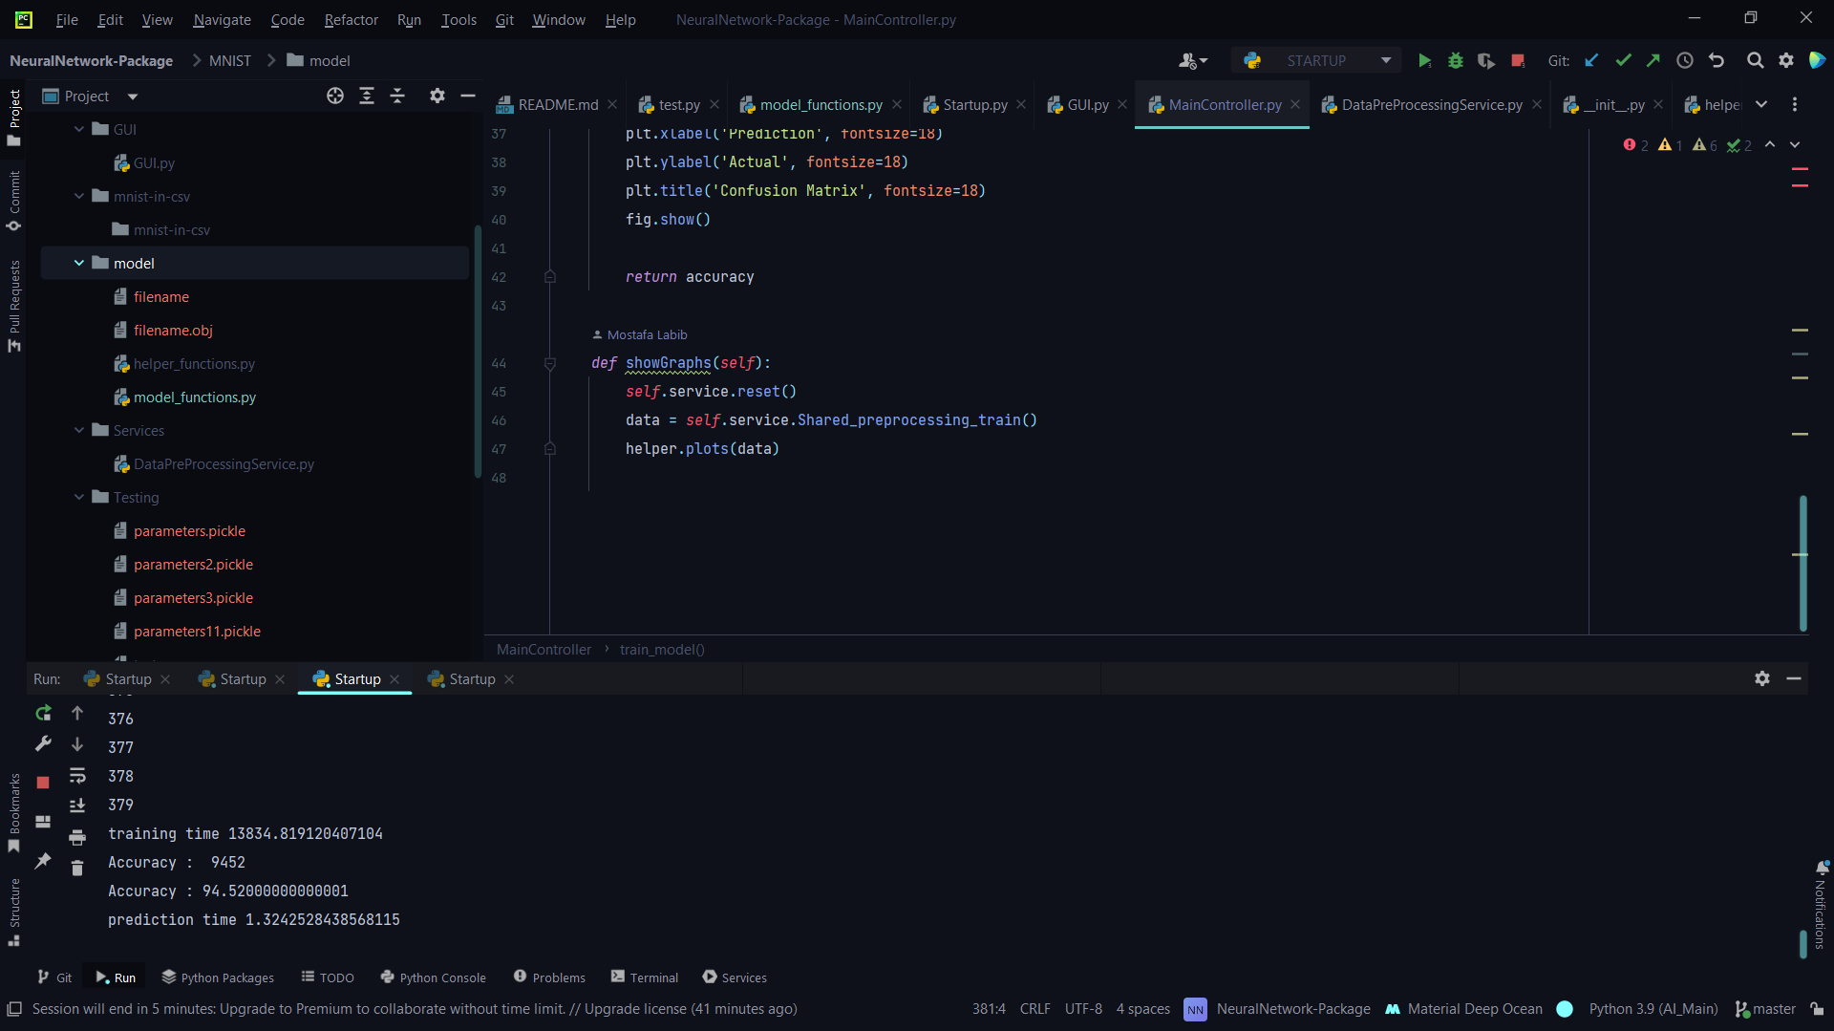

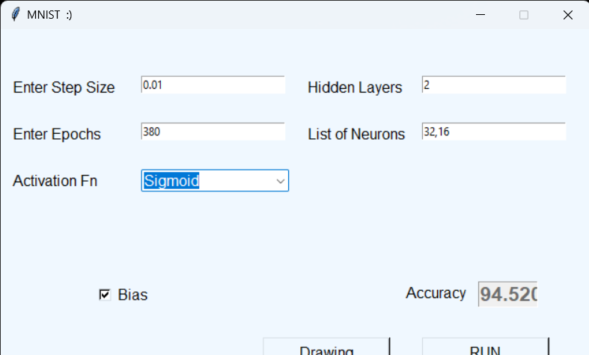

|  |  |  |  |  |  |  |  |
| --- | --- | --- | --- | --- | --- | --- | --- |
| **Activation Function** | **Train Accuracy** | **Test Accuracy** | **LR** | **Epochs** | **#Layers** | **#Hidden**  **Neurons** | **Training Time** |
| sigmoid | 95.1 | 94.4 | 0.01 | 240 | 3 | 64,32,16 | 12050sec |
| sigmoid | 95.5 | 94.45 | 0.01 | 240 | 2 | 32,16 | 9322sec |
| sigmoid | 92.8 | 92.2 | 0.01 | 30 | 2 | 32,16 | 1205 |
| tanh | 80 | 75.8 | 0.01 | 500 | 2 | 32,16 | 9050 |
|  | 95 | 94.52 | 0.01 | 380 | 2 | 32,16 | 13834 |